| **Item**  **No.** | **Task/Activity Description** | **Inspection/Test** | | | | | **Action Point** | **Responsibility** | **Comments** |
| --- | --- | --- | --- | --- | --- | --- | --- | --- | --- |
| **Frequency** | **Acceptance Criteria** | **Reference Documents** | **Inspection/Test Method** | **Record of conformity** | **FH** | **Client** | **Date** |
| **1** | **Preliminary Works** | | | | | | | | | | | |
| 1.1 | Check for correct documentation | Prior to commencing any activity | Ensure that all employees and subcontractors are:  -using the correct and complete set of drawings  -all drawings are the latest revision | Drawings  C10, C11  C12, C20  C21, C22  C30, C31  C40, C41  C42,C43  C44, C45  C50, C60 C61 | Visual Inspection | Signed ITP | HP | Project Manager |  |  |  |  |
| 1.3 | Implementation of all measures and controls | Prior to commencing any activity | All necessary measures and controls are being implemented, that is: EMP,& SWMS. | EMP  SWMS | Visual Inspection | Signed ITP | HP | Project Manager |  |  |  |  |
| **2** | **Construction Works** | | | | | | | | | | | |
| 2.1 | Survey Set-Out | Prior to commencement of excavation. | Area has been set out in accordance with the drawings | Work Procedure | Verify using GPS Model | Signed ITP | IP | Site Supervisor |  |  |  |  |
| 2.2 | Excavation Permit | Each Lot | An excavation permit or DBYD must be issued prior to any excavation commencing. Plant and equipment shall be appropriate for the task. Excavation operations shall not disturb areas outside the limit of excavation | Excavation Permit | Verify | Signed ITP | HP | Project Manager |  |  |  |  |
| **Lot 1** | | | | | | | | | | | | |
| 3.1 | Subgrade Material Properties | Each Lot | In situ material within 400mm of cut floor level to be consistent with Type B. i.e. CBR>assigned value (must be greater than 2), Swell < 2.5%.  If parameter met, rip and re compact 150mm. If parameters not met remove 400mm of material and replace with conforming type B. |  | Site Inspection  Test Report | Signed ITP  Test Report | TP | Site Supervisor  Geotech Inspection |  |  |  |  |
| 3.2 | Subgrade Inspection of Material | Each Lot | Prior to commencing excavation in any area and during excavation work inspect each type of material encountered and subject to verification by appropriate laboratory testing, agree on the category of the material |  | Visual Inspection | Signed ITP | HP | Site Supervisor |  |  |  |  |
| 3.3 | Subgrade Material Classified as Silt | Prior to commencing | Material classified as silt, either before or after compaction, is not acceptable as Type A material without stabilisation to the satisfaction of the Geotech Engineer |  | Visual Inspection | Signed ITP  Area treated detailed on marked up drawing | HP | Site Supervisor |  |  |  |  |
| 3.4 | Subgrade Acceptance | Prior construction of the regulating layer. | Prior to construction of the regulating layer, the areas of subgrade shall be presented for acceptance.  Bulk Excavation Level Confirmed | Drawings | Site Inspection  Document Review  GPS Model  Proof Rolling | Signed ITP  Photos  Videos | HP | Project Manager  Site Supervisor |  |  |  |  |
| 3.5 | Subgrade Unsuitable Material | Each lot as required | Where unsuitable material is encountered, proposed in-situ treatment must be submitted to the Project Manager for review. |  | Visual Inspection  Proof Roll | Signed ITP & Test Reports | HP | Project Manager  Site Supervisor |  |  |  |  |
| 3.6 | Subgrade Groundwater | Each lot as required | Where groundwater is encountered the contractor shall notify the Project Manager who shall submit any necessary approvals from relevant authorities for the treatment and disposal of this groundwater. |  | Visual Inspection | Signed ITP & Test Reports | HP | Project Manager  Site Supervisor |  |  |  |  |
| 3.7 | Subbase – Rock Placement | Each lot as required | 200mm Compacted Thickness of 40mm recycled crushed concrete placed in 100mm layers | Drawings | Site Inspection/ GPS Survey Report | GPS Survey | SCP | Project Manager  Site Supervisor |  |  |  |  |
| 3.8 | Subbase – Rock Placement | Each lot as required | 200mm Compacted Thickness of 20mm Class 2 crushed rock placed in 100mm layers | Drawings | Site Inspection/ GPS Survey Report | GPS Survey | SCP | Project Manager  Site Supervisor |  |  |  |  |
| 3.9 | Subbase Trimming and level conformity | Each lot as required | The level at any point on the subgrade shall not lie more than 20 mm below a 3 m straightedge laid in any direction, except across a crown and water shall not pond at any point.  Level tolerances:  Range x = +5, -25mm  Max S = 15 mm  40 measurements per lot (Scale B) |  | Site Inspection/ GPS Survey Report | GPS Survey | SCP | Project Manager  Site Supervisor |  |  |  |  |
| 3.10 | Subbase Test Rolling | Each lot as required | No visible deformation or springing.  Pneumatic tyred plant nominated for test rolling procedures shall have a mass of not less than 15 tonne and shall have a ground contact pressure under either the front or rear wheels of not less than 450 kPa per tyre. |  | Visual Inspection | Signed ITP  Photos  Videos | HP/WP | Project Manager  Site Supervisor |  |  |  |  |
| 3.11 | Subbase Compaction Testing | Each lot as required | Subbase Rock layers to have minimum compaction 98%. | Drawings | Test Point | Signed ITP & Test Report | TP | Project Manager  Site Supervisor |  |  |  |  |
| **Lot 2** | | | | | | | | | | | | |
| 4.1 | Subgrade Material Properties | Each Lot | In situ material within 400mm of cut floor level to be consistent with Type B. i.e. CBR>assigned value (must be greater than 2), Swell < 2.5%.  If parameter met, rip and re compact 150mm. If parameters not met remove 400mm of material and replace with conforming type B. |  | Site Inspection  Test Report | Signed ITP  Test Report | TP | Site Supervisor  Geotech Inspection |  |  |  |  |
| 4.2 | Subgrade Inspection of Material | Each Lot | Prior to commencing excavation in any area and during excavation work inspect each type of material encountered and subject to verification by appropriate laboratory testing, agree on the category of the material |  | Visual Inspection | Signed ITP | HP | Site Supervisor |  |  |  |  |
| 4.3 | Subgrade Material Classified as Silt | Prior to commencing | Material classified as silt, either before or after compaction, is not acceptable as Type A material without stabilisation to the satisfaction of the Geotech Engineer |  | Visual Inspection | Signed ITP  Area treated detailed on marked up drawing | HP | Site Supervisor |  |  |  |  |
| 4.4 | Subgrade Acceptance | Prior construction of the regulating layer. | Prior to construction of the regulating layer, the areas of subgrade shall be presented for acceptance.  Bulk Excavation Level Confirmed | Drawings | Site Inspection  Document Review  GPS Model  Proof Rolling | Signed ITP  Photos  Videos | HP | Project Manager  Site Supervisor |  |  |  |  |
| 4.5 | Subgrade Unsuitable Material | Each lot as required | Where unsuitable material is encountered, proposed in-situ treatment must be submitted to the Project Manager for review. |  | Visual Inspection  Proof Roll | Signed ITP & Test Reports | HP | Project Manager  Site Supervisor |  |  |  |  |
| 4.6 | Subgrade Groundwater | Each lot as required | Where groundwater is encountered the contractor shall notify the Project Manager who shall submit any necessary approvals from relevant authorities for the treatment and disposal of this groundwater. |  | Visual Inspection | Signed ITP & Test Reports | HP | Project Manager  Site Supervisor |  |  |  |  |
| 4.7 | Subbase – Rock Placement | Each lot as required | 200mm Compacted Thickness of 40mm recycled crushed concrete placed in 100mm layers | Drawings | Site Inspection/ GPS Survey Report | GPS Survey | SCP | Project Manager  Site Supervisor |  |  |  |  |
| 4.8 | Subbase – Rock Placement | Each lot as required | 200mm Compacted Thickness of 20mm Class 2 crushed rock placed in 100mm layers | Drawings | Site Inspection/ GPS Survey Report | GPS Survey | SCP | Project Manager  Site Supervisor |  |  |  |  |
| 4.9 | Subbase Trimming and level conformity | Each lot as required | The level at any point on the subgrade shall not lie more than 20 mm below a 3 m straightedge laid in any direction, except across a crown and water shall not pond at any point.  Level tolerances:  Range x = +5, -25mm  Max S = 15 mm  40 measurements per lot (Scale B) |  | Site Inspection/ GPS Survey Report | GPS Survey | SCP | Project Manager  Site Supervisor |  |  |  |  |
| 4.10 | Subbase Test Rolling | Each lot as required | No visible deformation or springing.  Pneumatic tyred plant nominated for test rolling procedures shall have a mass of not less than 15 tonne and shall have a ground contact pressure under either the front or rear wheels of not less than 450 kPa per tyre. |  | Visual Inspection | Signed ITP  Photos  Videos | HP/WP | Project Manager  Site Supervisor |  |  |  |  |
| 4.11 | Subbase Compaction Testing | Each lot as required | Subbase Rock layers to have minimum compaction 98%. | Drawings | Test Point | Signed ITP & Test Report | TP | Project Manager  Site Supervisor |  |  |  |  |
| **Lot 3** | | | | | | | | | | | | |
| 5.1 | Subgrade Material Properties | Each Lot | In situ material within 400mm of cut floor level to be consistent with Type B. i.e. CBR>assigned value (must be greater than 2), Swell < 2.5%.  If parameter met, rip and re compact 150mm. If parameters not met remove 400mm of material and replace with conforming type B. |  | Site Inspection  Test Report | Signed ITP  Test Report | TP | Site Supervisor  Geotech Inspection |  |  |  |  |
| 5.2 | Subgrade Inspection of Material | Each Lot | Prior to commencing excavation in any area and during excavation work inspect each type of material encountered and subject to verification by appropriate laboratory testing, agree on the category of the material |  | Visual Inspection | Signed ITP | HP | Site Supervisor |  |  |  |  |
| 5.3 | Subgrade Material Classified as Silt | Prior to commencing | Material classified as silt, either before or after compaction, is not acceptable as Type A material without stabilisation to the satisfaction of the Geotech Engineer |  | Visual Inspection | Signed ITP  Area treated detailed on marked up drawing | HP | Site Supervisor |  |  |  |  |
| 5.4 | Subgrade Acceptance | Prior construction of the regulating layer. | Prior to construction of the regulating layer, the areas of subgrade shall be presented for acceptance.  Bulk Excavation Level Confirmed | Drawings | Site Inspection  Document Review  GPS Model  Proof Rolling | Signed ITP  Photos  Videos | HP | Project Manager  Site Supervisor |  |  |  |  |
| 5.5 | Subgrade Unsuitable Material | Each lot as required | Where unsuitable material is encountered, proposed in-situ treatment must be submitted to the Project Manager for review. |  | Visual Inspection  Proof Roll | Signed ITP & Test Reports | HP | Project Manager  Site Supervisor |  |  |  |  |
| 5.6 | Subgrade Groundwater | Each lot as required | Where groundwater is encountered the contractor shall notify the Project Manager who shall submit any necessary approvals from relevant authorities for the treatment and disposal of this groundwater. |  | Visual Inspection | Signed ITP & Test Reports | HP | Project Manager  Site Supervisor |  |  |  |  |
| 5.7 | Subbase – Rock Placement | Each lot as required | 200mm Compacted Thickness of 40mm recycled crushed concrete placed in 100mm layers | Drawings | Site Inspection/ GPS Survey Report | GPS Survey | SCP | Project Manager  Site Supervisor |  |  |  |  |
| 5.8 | Subbase – Rock Placement | Each lot as required | 200mm Compacted Thickness of 20mm Class 2 crushed rock placed in 100mm layers | Drawings | Site Inspection/ GPS Survey Report | GPS Survey | SCP | Project Manager  Site Supervisor |  |  |  |  |
| 5.9 | Subbase Trimming and level conformity | Each lot as required | The level at any point on the subgrade shall not lie more than 20 mm below a 3 m straightedge laid in any direction, except across a crown and water shall not pond at any point.  Level tolerances:  Range x = +5, -25mm  Max S = 15 mm  40 measurements per lot (Scale B) |  | Site Inspection/ GPS Survey Report | GPS Survey | SCP | Project Manager  Site Supervisor |  |  |  |  |
| 5.10 | Subbase Test Rolling | Each lot as required | Rock layers to have minimum compaction 98%. |  | Test Point | Signed ITP & Test Report | TP | Project Manager  Site Supervisor |  |  |  |  |
| 5.11 | Subbase Compaction Testing | Each lot as required | Subbase Rock layers to have minimum compaction 98%. | Drawings | Test Point | Signed ITP & Test Report | TP | Project Manager  Site Supervisor |  |  |  |  |

**APPENDIX**

**Figure 1: Table 204.142 Minimum Frequency of Testing for Compaction and Moisture Content**

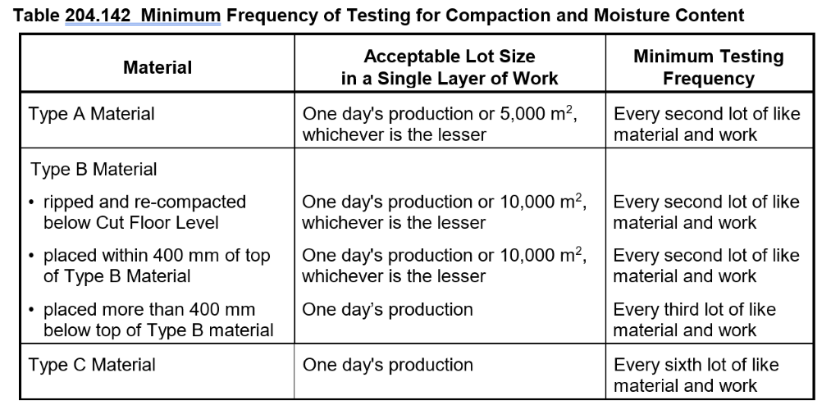

***Figure 2: Table 204.131 Compaction Requirements***

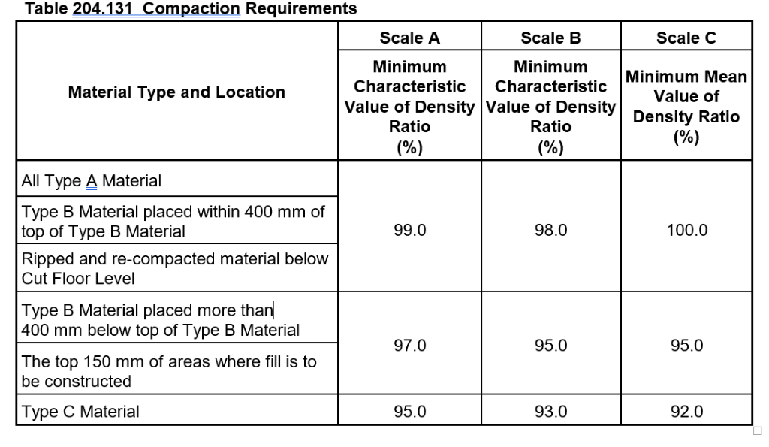

|  |
| --- |
| **Final Inspection** The signature below verifies that this ITP has been completed in accordance with the SWA’s Quality system Procedures and verifies lot compliance with specifications.  **Print Name: Position: Signature: Date: / /** |

**Legend:**

|  |  |  |  |  |  |
| --- | --- | --- | --- | --- | --- |
| **HP** | Hold Point | Work shall not proceed past the HP until released by the Superintendent | **IP** | Inspection point | Formal Inspection to be done and recorded |
| **HP\*** | SWA Hold Point | Work shall not proceed past the HP* until released by the SWA | **TP** | Test Point | Product compliance test to be undertaken and recorded/reported |
| **WP** | Witness Point | An inspection which must be witnessed by the Superintendent | **SCP** | Survey conformance point | A qualified surveyor to check product/section/structure and report |
| **AP** | Approval Point | Written or verbal approval given by the Superintendent |  |  | |